Delegate’s Written Report for the 2019 Summer Assembly– July 20, 2019
_________________________________________________________________________________________________
Notes:
- This report can be found on the Delegate’s Page at www.Al-Anon-CO.org .
- To download a copies of my Delegate Presentations and Copies of the PSA’s that we played at the 2019 CO Summer Assembly go to the Following link:
https://www.dropbox.com/sh/j4ilom7a02crqsx/AACJXTXBqcKdcqYChy47WAhYa?dl=0
- And to read or download a PDF copy of the “2019 WSC Summary” go to this link: https://al-anon.org/for-members/world-service-conference-wsc/world-service-conference-summary/
_________________________________________________________________________________________________
Dear Colorado Al-Anon Members,

On April 12-18, I attended the 2019 World Service Conference! It was an Amazing Adventure! The 2019 WSC Theme was:
ACTION is ATTRACTION- There is NO Growth in the Comfort Zone!
L’action, c’est l’attrait – Il n’y a pas de croissance dans la zone de confort
La acción es atracción – No hay crecimiento en la zona de comodidad

And it was the first WSC ever to be Conducted in Three Languages, English, Spanish, and French!

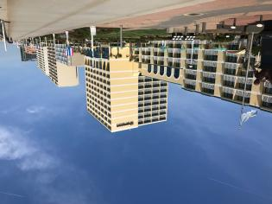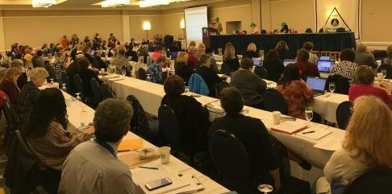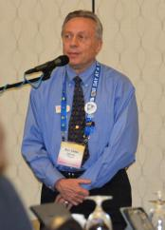
Photos: Sheraton Hotel, Members of the Conference “in Action”, and “my first of many times at the mic”

My Thoughts on the Conference:
- Best thing I heard at conference: Give God something to work with, just be yourself!
- The Conference was all about The Practice of Putting Unconditional Love into Action!
- The World Service Conference was a combined Assembly, world’s largest Al-Anon Group Conscience, and a Business Meeting. It wasn’t perfect, but it was completely permeated by our spiritual principles! The foremost of which was the Unconditional Love in Action that was freely expressed between all the conference members! I have never experienced so much support, help, and encouragement from a group or organization before!
- Experiencing it filled me up spiritually! When we put love into action, it is Service! If you want to get a sense of how I felt, please read the following selected quotations taken from How Al-Anon Works, copyright 2008 by Al-Anon Family Group Headquarters, Inc. Reprinted by permission of Al-Anon Family Group Headquarters, Inc.”

PUTTING LOVE INTO ACTION
We hear a lot in Al-Anon about unconditional love. Such love makes no demands, exacts no payment, has no expectations. We are free to give it without anticipating or even wanting anything in return because the experience of loving in this way is so rewarding in and of itself that we are grateful for the opportunity. Often without being aware of it, we receive love of this kind without any sense of obligation to pay it back and without fear that the bill will come tomorrow…
Unconditional love asks for nothing except expression. It blesses both the giver and the receiver… Our survival as a fellowship depends on unconditional love. We are brought together through a common problem and united by a common goal. We need each other. Each member is important, yet nothing is required of any member except what he or she freely wishes to give…
It takes practice to learn to love unconditionally… Service in Al-Anon allows us to stretch ourselves and to practice the Al-Anon principles while we connect with others with whom we can be ourselves. It is an opportunity to attempt something we actually can achieve and to gain self-esteem by doing something of value.
We discover that when we reach out to others, our own pain diminishes, and our recovery begins to soar… Part of that self-caring involves understanding that love is not lessened when given away. In fact, the more love we offer, the more love we will find within ourselves. Thus, whenever we truly give of ourselves, almost magically we find that there is more of our selves to give.
Ironically, the only real way to keep the riches we receive is to give them away. By taking advantage of these opportunities to practice unconditional love, we make love an ongoing part of our lives and we learn that by giving, we always receive.”

  - I experienced all this, and I found myself very comfortable, willing to actively participate, invigorated, and able to positively contribute to the 2019 World Service Conference! I guess another way to think of it is I felt the presence of our “Unseen Member”!
- A special thanks to the groups in Districts 6, 8, 15, the Parent-Helping-Parent AFG, and the Keep It Simple AFG for all the love gifts that were sent to share with the other Delegates, Trustees, and WSO staff! Besides the many delicious treats, everyone loved the Colorado Post Cards, “Keep Coming Back” business cards, “Spice Up Your Recovery” chili beads, the “Growing in Recovery! Colorado wildflower seeds, and everyone wanted to grab a bag of COLORADO “Moose Droppings”!
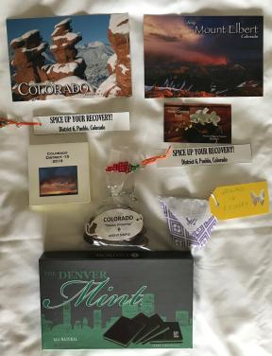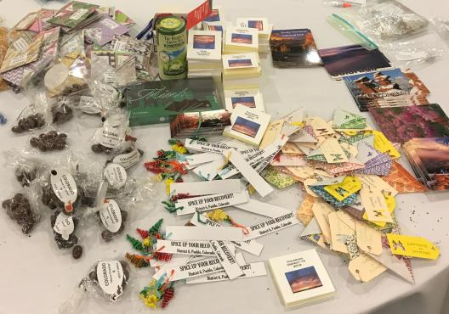
Photos: Love Gifts from Colorado for other Delegates, Trustees, and WSO Staff!
What Generally Happened in the 6 Days of Conference:
- The Conference Leadership Team and the Conference Chairperson insured the 5 day-long conference was Organized, Engaging, Interesting, and Productive. Amazingly, I was never bored or uninterested, but I did become very tired at the end of each day! Sorry about that, next year I promise to be in better shape, and I will try to email short updates of each day’s events to you. The Conference is a testament to the extensive amount of thought and planning that is done in advance to make it a success. It is the same extra effort that is put into all the work that the World Service Office (WSO) does to support Al-Anon.
- The day before Conference started included Delegate’s Sharing of their Area Highlights. All the Delegates meet to review and discuss the top highlights from each Area. I learned that there is a very interesting increase in the number of Alateen meetings in Schools, it is the only area of Alateen growth. Boise Idaho Al-Anon is having difficulty finding enough AMIAS members to support all the Alateen meetings they have in their schools.
- The day prior to the Conference began with the new Delegate Orientation for the Panel 59 Delegates. The three Goals of the Orientation were;
  - Goal #1: Conference members will understand the purpose of the Conference, relationships within the service structure, and be able to articulate Conference Decisions.
  - Goal #2: The spiritual tone of the WSC will prevail by the demonstration of mutual respect and acceptable conduct by its members.
  - And Goal #3: Knowing that our Higher Power is present in the expression of our group conscience, Conference members will presume Goodwill.
- I selected to join the Public Outreach Committee, and we meet in the afternoon of the day prior to the Conference. The main topics discussed were:
  - Topic 1) that announcement that the Al-Anon Faces Alcoholism (AFA) was now available to be ordered at any time, and new orders for 2019 AFA could be made any time until inventory ran out (estimated to be sometime in late Nov.).
  - Topic 2) was about the development of two new PSA’s and making it easier for Stations to get the required quality copies for broadcasting. More on the exciting new PSA’s later in this report.
  - Topic 3) Website and Social Media Updates (Scot Director of Digital Strategy) said the Website is already 2 years old and needed updating and improvements, where were being worked on. They will be adding more video interviews on the 20 questions that are currently in production and will be added to the website and posted to the Al-Anon “Linked-in” pages and onto other Al-Anon Social Media sites.
  - Topic 4) they are updating the old LGBTQ pamphlets as they are very out of date.
  - Topic 5) they just released a new Fact Sheet for Professionals in pamphlet and PDF formats. The PDF versions in English, Spanish, and French can be found on the website at www.al-anon.org/resources-for-professionals/ .
  - Topic 6) was to prepare to launch all new outreach materials in English, Spanish, and French AT THE SAME TIME, before they are released to the Outreach Coordinators and the Groups.
  - New Business)
    - They have a need for two more members to assist with the development of “Benefits of Al-Anon” quotations to be posted on all the various Social Media platforms.
    - They were looking for a paid Spanish Translator and Al-Anon member and I forwarded this opportunity to CO District 25 (Spanish Speaking Groups).
    - They were also looking for an English and Spanish speaker to join an Outreach Committee that will ensure all Outreach literature is Culturally sensitive to the Spanish Community, I also forwarded this opportunity to our CO District 25.
    - And there was a new Outreach Committee that is developing new Outreach Materials on taking meetings into Jails and Prisons, that needed a member volunteer that is currently taking meetings into Prisons/Jails. I forwarded that opportunity to Colorado’s Donna D.
  - I also had the good fortune to speak privately with Claire R. the Associate Director- Professionals. One of the new Goals of AFG Inc. is to develop evidence-based research that proves Al-Anon and Alateen are helpful. When I was the CO Alateen Coordinator, I discovered that there were many Alateen in School meetings that worked very closely with the School Counselors. I am now working with Claire to see if it is possible to try to collect anonymous data from the school counselors on the adolescents from Alcoholic/Drug Addicted homes that are attending and that are not attending the Alateen meetings to determine if there is evidence that regular Alateen meeting attendance is helpful to the adolescents. Brook from District 16 may be assisting with this effort.
  - Finally, there are many very large Social Media Al-Anon groups that are not registered with WSO and the Al-Anon Copyright is at risk of being lost unless Al-Anon can convince them to register with WSO. The Al-Anon lawyers are preparing to address those Social Media Groups that decide not to register with WSO, as they will no longer be able to use the Al-Anon name.
- Day one began with a great Skit presented by the Thought Force on “Welcoming Potential Members of Families of Drug Addiction”. *I AM LOOKING FOR VOLUNTEERS TO DO THE SAME SKIT AT THE SUMMER ASSEMBLY, please let me know if the Actor/Actress inside of you needs to be expressed!
We followed the Skit with a breakout session on “Welcoming Potential Members of Families of Drug Addiction”. It was very helpful, and we did a Breakout Session at the Summer Assembly on the Same Topic!
- The WSO Staff reported on all the work they did in 2018.
  - Each of the associate directors reported on the work they did in 2018, including, Vali F. the Executive Director of WSO who discussed the importance of the new Strategic Plan and its implementation. Each of the department managers submitted their plans to achieve the Strategic Goals, there were 25 in total, but not enough available money to support all of them at once. There are now three different Leadership Teams, the “Staff Management Team”, the Strategic AFG HQ Inc. Team, and a Team for Proposing Policy and Literature Changes.
  - Scot, (Associate Director of Digital Strategy), introduced two new Public Service Announcements (PSA) for 2019! The new “Challenger” PSA is very exciting! It is derived from our “Al-Anon 20 Questions” flyer and was created to appeal all possible Al-Anon members. The new “Champion” PSA is in the style of our past PSA’s and it is targeted to a subset of possible new Al-Anon members, in this case the wives of Alcoholics. Which one do you like the most? To play them both, here is the dropbox link: https://www.dropbox.com/sh/a0n3xc8ty9bsm1n/AAD6_LhMRxTyXyEsAx9dUKlCa?dl=0
  - And Scot explained how the new Al-Anon.org Website continues to improve and expand! Please check it out and explore all the different pages! To do that go to www.Al-Anon.Org and discover how valuable it is! I will take some time during my Report at the Summer Assembly to show you the features of the new Al-Anon Website.
  - The financial review was given my Niketa Bailey (Director of Finance and Operations). It was very clear, and I will share a simplified version with you at the Summer Assembly. I will also provide a one sheet summary of useful information that you can take to your Group for distribution.
  - Marsha Ware (Programs Director), Sue Perez (Associate Director- Group Services), Karri Kindelan (Associate Director- International), Tom Coffey (Associate Director- Literature), and Claire Ricewasser (Associate Director- Professionals) all gave their reports. The details for each of their reports will show up in the 2019 WSC Summary that will publish and be posted on the www.Al-Anon.Org website at the time of the Summer Assembly.
- The mega issue was a discussion and brainstorming of the possible new ways to utilize electronic tools to improve the WSC and make it more effective. Many Delegates thought that not everyone can devote 6 straight days to the Conference, but it was an absolute must that the members of the Conference have the Face-to-Face time to discuss topics. The members suggested many possibilities and options which will be considered in the future. It is possible that the Colorado Area could also benefit from using digital technology to make our Assemblies only require a one-night hotel stay. This would lower the cost to our Groups to send a GR to Assemblies.
- The Policy committee reviewed the changes to the Alateen section of the Service Manual. Our Area will need to review them. It suggests that the AMIAS should be trained prior to engaging in Alateen meetings. Also, the Alateen meetings need to approve any substitute AMIAS for each of their meetings. We will need to start the conversations in our Area on these topics.
- The Trustees have decided to stop doing the TEAM events, because it seems to not be the best utilization of their time. They are re-envisioning Team and Road Trips. It was good that Colorado already had a TEAM event, as other Areas will not be able to have one.
- The Trustees Bylaws Task Force concluded 17 months of work updating the Bylaws. The changes were reviewed and approved by the Conference.
- Al-Anon is preparing to support the 2020 A.A. International Convention. We learned that as many Al-Anon members attend it as attended the last Al-Anon International Convention. It is a big deal and a large effort is required to support all the Al-Anon activities.
- We learned about all the work the Trustee do. It is a large time and work commitment on their part. They are not paid for their time, only travel expenses are reimbursed. We learned about many details of what it was like to be a Trustee. The Trustees are our trusted leaders and are responsible for the business of Al-Anon and the directions Al-Anon will need to go to remain strong, relevant, and available to the Families of Alcoholics well into the future. They are responsible for updating our Policies and the approval of all Literature. I was an honor for be to get to know such dedicated people!
- We discussed the following activities of the Policy Work Group on Electronic Meetings and, as said before, Al-Anon is actively working to get those Social Group Meetings that are using the Al-Anon name to register with WSO.
- The International Coordination Committee spoke about World Al-Anon and the many General Service Offices around the WORLD. Each country has created one that respects their cultural traditions and, yet, is still 100% Al-Anon. All of them follow the lead and example of the USA and Canada World Service Office. The International Al-Anon General Services Meeting (IAGSM) is a biennial service meeting for General Service Offices/national service structures. They reported on the 2018 meeting and you can find the summary on our website under members/international tabs.
- 2018 Audit and 2019 Budget details can be found in my 2019 Summer Delegates Presentation Report at the following link: https://www.dropbox.com/sh/j4ilom7a02crqsx/AACJXTXBqcKdcqYChy47WAhYa?dl=0 .
Key 2018 Audit and 2019 Budget Presentation slides follow:
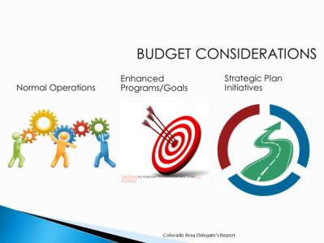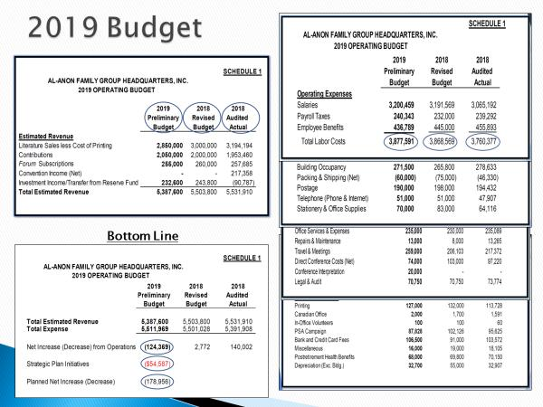
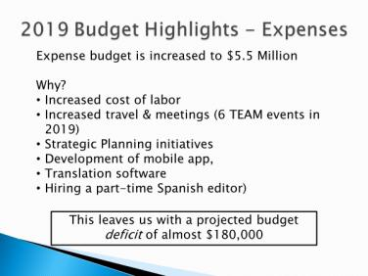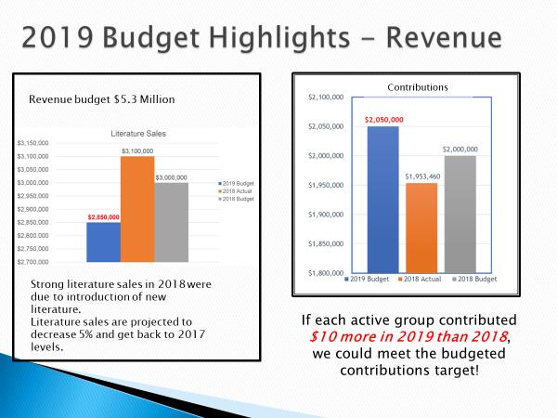
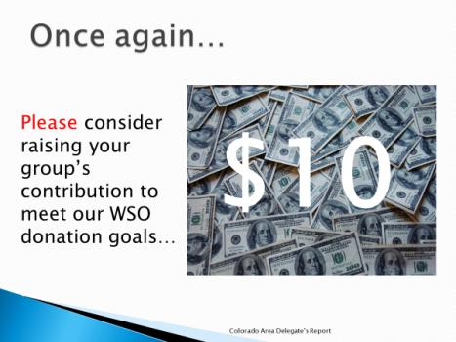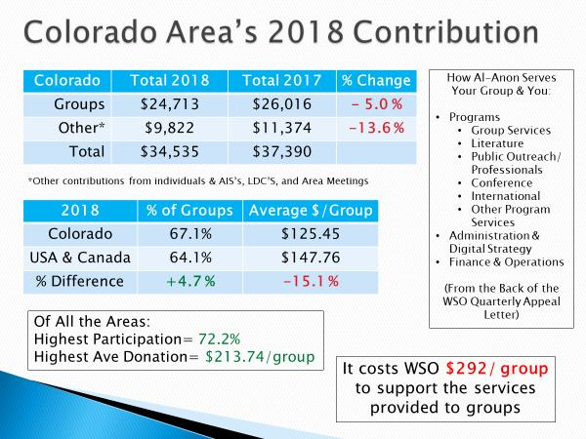
- Motions from the 2019 WSC follow in these slides:
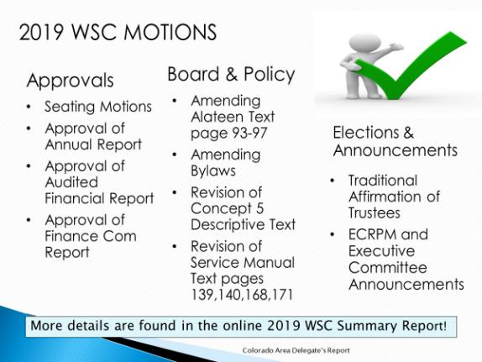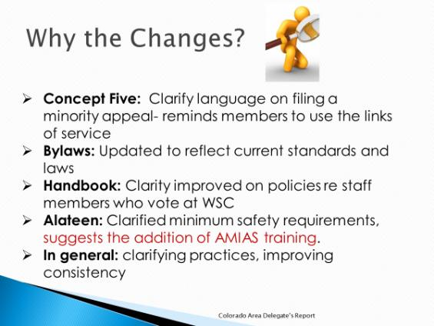
- During the breakfasts, lunches, and dinners, I had a great opportunity to be seated next to many of the key WSO Staff and many of the Trustees. That was super valuable, and I grew to understand that every single one of them truly Loves Al-Anon and it was simply a labor of love for them to make it as good as it can be. I had multiple strategic discussions with them and realized there is not enough funds available to achieve all Al-Anon’s Strategic Goals in the desired time frame. We discussed the possibility of utilizing more Al-Anon members with the specific skill sets needed to accomplish the Goals and how that might be accomplished. Everyone was receptive and interested in those discussions.
- I now fully understand the large amount of hard work the Al-Anon staff and Al-Anon volunteers accomplished in 2018, and it was all done within the budget. It is just amazing to me that they accomplish so much! I believe it is much more work than a “for profit company” would accomplish with the same number of people and the same budget! And it is clear to me, their Love of Al-Anon and the desire to make it as helpful and useful as possible to the Families of Alcoholics is the reason!

Summary:
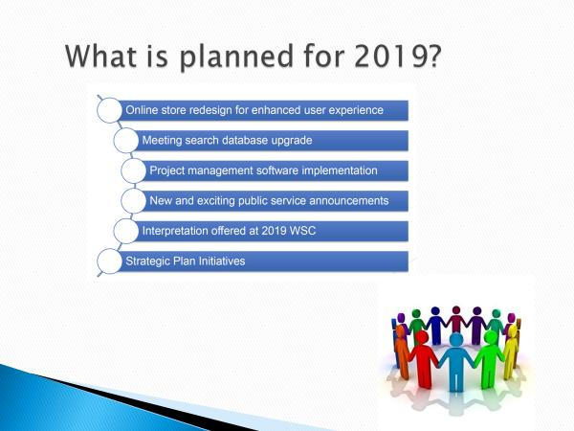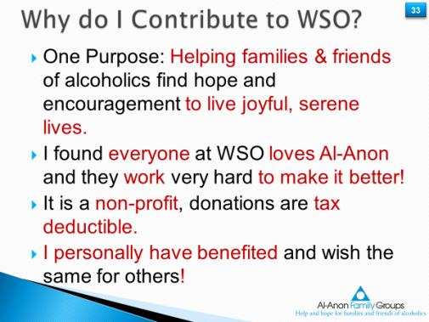

It was a wonderful learning experience and an amazing adventure in Service, Recovery, and Spiritual Growth! Thank you for all the cards and good wishes! Looking forward to seeing you all at the Summer Assembly! And finally, Al-Anon relies on the contributions of Members and sales of CAL literature, I can’t think of a single better investment in our future, than to increase my personal donations to WSO!

Thanks for all you do for Al-Anon! Best wishes for continued peace and serenity in the Al-Anon program.

With deep gratitude,
Rick Godec
Colorado Delegate Panel 59
Delegate@Al-Anon-CO.ORG
720-759-9414

