COLORADO AREA AL-ANON SPRING ASSEMBLY
March 15-17, 2019 - Colorado Springs, Colorado
DRAFT MINUTES

Assembly Opening ​– Christy opened with the Serenity Prayer and a reading of the Twelve Concepts & Warranties. Christy stated the purpose of the Assembly and gave a special welcome to the Past Delegates.
Host Announcements ​– Kim with District 16 gave us the lowdown on the facility, lunch options, AA Coffee and Ice Cream tickets, lost and found, etc.
Assembly Rules​ - Dennis G., Past Delegate, Panel 38 welcomed all new GRs and helped them identify basic Assembly rules and manners.
Roll Call​ - Meg Secretary asked for a Group Representative countdown and would use the registration sign in book for the purposes of counting the voting members. There were 82 members present. Actual roll will be posted as Addendum #1 to the Minutes.
Approval of Minutes -​ Donna moved to accept the minutes from November 2018 Assembly, Donna (Inside Job GR) seconded the motion. The motion carried, no nays, 6 abstentions.
Officers Reports​ -
Chair Christy: I want to start by thanking you for your generosity in deciding to send me to the Southwest Regional Delegates Meeting (SWRDM) last week. This years event took place in Hilo, HI and I feel so very privileged to have been able to attend. I met so many wonderful Al-Anon members who were current and past-delegates, past and current chairs, trustees, and many more. I was able to experience the respect, courtesy, love and cooperation that exists within this fellowship. What a wonderful example of working together for a shared goal of helping the fellowship of Al-Anon/Alateen move forward. Thank you so very much.
As Chair, I’ve had the opportunity to get to know some of you, but still have yet to meet many of you, especially our newest members. Please come and introduce yourself to me ~ I want to know who you are and welcome you to our Assembly family.

Excerpt taken from 2018 World Service Conference Summary under “Conference Theme and Opening Remarks” pg. 9 - I have taken some liberties and substituted our Area terms for WSC terms …. reminds me why I’m here and why I serve the Al-Anon/Alateen Family Groups:

“Our purpose at this Assembly is to ensure that our Area continue under all conditions. We are here to act on behalf of Al-Anon as a whole. We are here to apply the spiritual principles of our program as we conduct the business of Al-Anon. Obviously we did not come here to simply sit or stand still! We come in the spirit of freedom - Al-Anon’s most cherished liberty - to participate as equals and to share service ideas and experiences with each other.”
“May each of us also come with an open mind and a renewed commitment to service, appreciating the privilege of having a seat at this Assembly and representing the fellowship. I am hopeful that our work here this weekend will inspire other members to act - to step forward and to participate - so that Al-Anon and Alateen’s message of recovery is heard throughout Colorado and our services remain available to every current member, every group, every potential member and every group not yet formed.”

Kari Alt Delegate: Working on task & thought forces, more later regarding budget thought force. Our Area is in a great position. Learned from the SWARDM that many Areas are not.
Meg Secretary: I am just becoming acquainted with Google and learned how to store files on “the cloud” per our IT/Media Recommendations that were adopted last year. Plans to send out minutes in draft form via email within a month or so after the Assembly. Is working on cleaning up the Motions Document with the help of Ernie and creating an index for this.
Grete Treasurer: Will have a larger presentation later. Hopes to make reports available timely on the Website and try to take the mystery out of Area finances. Grete shared about the 7th tradition and started the bedazzled can around the room. She will pass around now and then will keep it up front near her. She will report on this tomorrow.
Rick Delegate: 30 minute report. Shared about how valuable it was to attend SWARDM. He will be doing a workshop with the GRs later today and using that information to take back to his first Conference in April. See attached presentation Addendum #2 and/or information on the Delegate’s page of the Website for loads of good information, inspiration and food for recovery.
Area Banner -​ DRs are asked to count the number of GRs present from their district and provide that to Host Committee for calculation of the quilt banner winner for this Assembly. Christy explained we will need a new blank quilt to start with after next two assemblies.
What’s the Ask-it-Basket?​ - Marilyn Past Delegate, Panel 53, said there are many ways to get your questions answered. If you can’t get an answer by the end of the assembly today, put it in the Ask It Basket and it will be answered tomorrow morning and published in the Area Minutes. Sometimes we want our question to be anonymous. Marilyn read a sample Ask it Basket question. She also asked that Past Delegates stay around after Assembly ends tonight so she can get help answering the questions tomorrow morning.
Old Business - Thought/Task Forces
Website Task Force – Steve B, Website Coordinator – New website up and running. Interacts well with Google. Great job to Linda for getting this up and running. There is still work to do, ongoing.
Alateen Guidelines Task Force – Tom B. Past Delegate Panel 47 – We are formalizing procedures in case of a complaint against an AMIAS. Will have a presentation at next assembly then will need to go to legal before we can vote to adopt into our guidelines.
Spanish Translation Task Force –Brooke - The Task Force Charge we were given is as follows:
Draft a position description for a Spanish Translation Coordinator for Area 5 Colorado.
To include:
- “Duties shared by all coordinators”
- Define Duties/Responsibilities of the Spanish Translation Coordinator
- Define Basic Skills/Experience Needed
- Define Equipment and Technical skills needed
- Any additional items necessary to fulfill the position (from Service Manual/WSO/Etc.)

We began working on our charge on Sunday, March 3, 2019, with a teleconference. Debbe and I attended, and we discussed the charge and what we thought would be an appropriate beginning. As of Sunday, March 10, we were asked to put the Task Force on hold while the Area Chair determines additional information. As a result, what we have for a report is that we have started on a draft position description which we hope to have completed by the July Assembly so we can submit it for your feedback. We are asking for more volunteers to serve on this Task Force, including individuals who are bilingual.
Please see Addendum #3
There is a need for the Assembly to approve payment for translation services for another year. TMF, GR in Fort Collins moved that we provide permanent Spanish Translator expenses up to $675 annually as is consistent with other coordinator/officer travel expenses. Katherine seconded the motion as stated.
There were many questions and comments:
*Do we have members willing to be translator? It was noted we have a couple of unfunded members who have been serving as translators.
*It was clarified that this is travel expenses for translators, not the Spanish Translation Coordinator position.
*Is just for 2019? Is one translator enough?
*Clarification that interpreter is the spoken word, translation refers to the written word.
*Would like to see this is permanent, not discussing every year.
*How does this affect the budget be if the amount needed goes over this figure? Kari expressed that finance committee has latitude to cover this.
*Can line item be added for every event that the area does, for example Conventions.
*It was explained that this is not the end of the subject, many of the issues and concerns expressed will be addressed with the work of the task force.
*A member mentioned that she works with folks with disabilities. Perhaps we could include sign language.
The discussion and Secretary got muddled here with wording, using “Colorado Area” instead of “Area 5” and other semantics, but the motion was amended and voted upon as follows:

We, the Assembly, move that we pay up to a total of $675.00 per year ($225.00 per Assembly) for travel-related expenses for otherwise unfunded Al-Anon members to provide Assembly Spanish interpretation services. The motion passed, with one abstention and no opposition.

Old Business (con’t) - Area 5 Budget Report & Discussion-
Kari – Alt Delegate - presented Ample reserve / budget presentation. Please see attached Addendum #4 and/or the Website.
Before addressing the LDC question from Kari’s presentation, Christy asked the Assembly for a simple affirmation vote on the November Assembly motion to eliminate the Literature Distribution Center from the Colorado Area. The Assembly affirmed.
Donna H. GR District 6, moved to accept the finance committee recommendation to amend the Area 5 annual budget.
*discussed the need to amend to say “Colorado” instead of Area 5.
The motion was amended by Donna, and Christy again seconded. The motion was presented upon as follows:
We, the Assembly, move to amend the current Colorado Area Budget by removing both the income and expense items relating to the operation of a Literature Distribution Center (LDC).
The motion passed, 2 opposed, no abstentions.
Kari suggests a thought force regarding ideas on how to utilize the surplus in the ample reserve. Discussion ensued:
*suggest that each coordinator make a wish list to submit to thought force.
*proposed seed money so we don’t start from scratch on this.
*budgeting or promoting Al-Anon billboard in English and Spanish. Promotion to increase membership.
*heard that WSO is in the negative. Money is like fertilizer – helping out WSO, but wants to know why they are in the red.
*some groups who are having trouble paying rent. Perhaps a scholarship or grant system to help with this.
*rural area and districts, work on technological connections to bring the groups together, greater communication thru technology.
*Consider military needs for Al-Anon
*resources to public outreach for various health care professional conferences.
*More $ for districts that can’t afford to representatives to assembly
*more translations of all stuff into Spanish
At the close of our discussion, Rick, current Delegate, suggested we incorporate all these good ideas into the proposal from last assembly.
Old Business (con’t) - Literature Coordinator Position Update & Discussion –
Michelle M., Past Delegate, Panel 35 announced that the Literature Coordinator position has not been filled since nobody stood for the position. She is just getting started with various position descriptions. We can look to WSO has guidelines. Also see the full presentation from last assembly regarding the Literature Coordinator position ad Addendum #5 or on the Website. It has been considered that we might want to combine the Forum Coordinator position with Literature Coordinator. Currently the Forum position in our area is unfunded.
Michelle asked to have a discussion, 2 minutes at the mic please.
*Debby, current Forum Coordinator, said since there are no longer any bank accounts with Literature to keep track of, she is talking to her higher power regarding the position if it becomes a combined with Forum.
* recommend that we take out the language about the money in the Literature Coordinator position description. It is not necessary that the Assembly vote on all these changes.
*Is this our choice to combine the two position? How different are the job descriptions and WSO Guidelines regarding each? Michelle noted there are lots of choices, not this or that. The choices are infinite.
*with LDC gone, what does the Literature Coordinator do? Michelle said to see the guidelines from WSO. It is about telling the Area about the books, doing workshops, promoting CAL.
*It was explained that the LDC was about selling literature, not promoting.
*combining the Forum with Literature Coordinator makes sense.
*are we currently asking for somebody to take this position?
*The Forum Coordinator is un-funded. What does that mean? That the Coordinator doesn’t get reimbursed for travel expenses.
*It was suggested that we could continue selling literature with changes to make the job less daunting like limiting inventory and the number of events that we sell at. Michelle explained that the current sales tax issues were fairly complicated and the Assembly had already voted upon the issue.
*can we get a team for Literature rather than just a Coordinator? It was said that Coordinators can form committees.
*perhaps we should keep the two separate positions, giving the opportunity for folks to serve.
*The Literature Coordinator is also a conduit with the WSO, actually very important with lots more to it. Keep this in mind.
It looks like we are in need of a thought force? Yes, lots of bobble heads. Michelle said she will talk to Christy so she can put this together.
Invitation to State Convention - We were presented with a fun skit. Come to Keystone for Greater Personal Freedom, it is a family affair. Presented by Brooke, Margarita & Malia.
Christy excused us for a lunch break. There will be two lunchtime speakers.
Assembly Resumes​ – We began with the Serenity Prayer
Host Announcements​ – Please turn in lanyards and chips when you leave these evening.
Coordinator Reports -
Julie R. – GR Connection Chair – There are feedback forms on the Butterfly table. Please fill them out and get candy and Service manuals for a 5 dollar donation. Jolene, Co-Chair asked all to please sign the attendance sheet.
Meg V.- WIA – The Weekend in Al-Anon is an occasion for members to gather for fun and fellowship, to seek renewal, relaxation, serenity, and personal growth in a beautiful Colorado mountain setting. The event will again be at the beautiful Glacier View Ranch. Save the Date flyers are available for dispersal on the table with the Moose. Registration will open June 1st. Then after August 31st, there will be a price increase. We are attempting to build anticipation by postponing the registration open date. Check the website after June 1st for registration forms.still need more volunteers. Please take several flyers back to your groups and look for registration forms the first of June.
Donna V. – Archives - I've researched various options on how to maintain a cultural Archives panel. I would like to see it simplified for retrieval. I'd like to enhance Archives by including as many Area and District events as possible. If you or any members of your District have any information on past workshops or events that you would like included in Archives, please send me your copies to: archives@al-anon-co.org. What I would like to do is simplify the Archives without disturbing the Providence. I've spoken with Joe Tierney, WSO Archivist, and was referred to Rocky Mountain Society Archivists (a Liberian in Steamboat Springs), who then referred me 2 Archivists at the Denver Central Library, and an Archivist who taught Archives at Denver University. I am researching information to see if students can help with this project to expedite it. After speaking with several Past Delegates, the question of confidentiality came up. There is a possibility that students may be able to help, as long as the students sign a confidentiality agreement, there hopefully will not be a problem.

Donna H. (filling in for Kathy who had work conflict) -AAPP – please remember March 31st deadline. Last year , 115 members were registered as AMIAS with 18 Alateen groups. Missing the registration deadline costs the Area lots of money.
Kevin - Public Outreach- I will be making larger presentation later.
Janet -DIA. Made a great plug for spring cleaning in Montrose. They are having a Dessert Dash. Please register. Please make sure your groups have the correct flyer with the correct time and contact information.
Annika - Alateen Coordinator. I will be available to AMIAS and Alateens when there are questions or service is needed. Going through AMIAS training modules put together by WSO. Getting to know the different Districts by number and Alateen meetings. My hope is to make training a mandatory part of the AMIAS procedure in Colorado, before a new AMIAS attends their first meeting as an AMIAS. Hopefully while the process of a thought and task force are happening, calling a mandatory training workshop for all Area 5 AMIAS to attend. Fine tuning a training workshop for AMIAS. Since coming into this position in January I have spent the most time getting situated with my new Area e-mail and AFG Connects I have had two conference calls: 1, with our Area's new panel of coordinators and officers & another with WSO and the other Alateen Coordinators! (exciting) Lastly, I keep being reminded that I am no better than anyone else and my Higher Power has placed me in this position to carry the message of Alateen and Al-Anon.
Denisha -Records Coordinator – please consider standing for this position. She is moving to Georgia. Process has been so simplified. She encourages all to consider.
Debby - Forum Coordinator. Who knows what it is? There are 474 subscriptions for the Forum being delivered in our State, that includes groups. She will be conducting writing workshops soon in her home district. Please submit your story to the Forum and remember she is unfunded, so do it.
Experience: New Coordinator, finally got into the email in February. Had a great call with Claire R at WSO on what to use for my table at Assembly, then got further help in the Forum Connects. Very glad we we used the Forum as our study in a home group years ago in AZ.

Strength: Currently working on a Writing Assembly in my district to get practice
Created my trifold board for Spring Assembly
Printed 100 Forum writing submissions

Hope: All FC's have been asked by WSO to do our own story and submit.

Also advised you can read the Forum online, if need help come ask me. Asked all districts to contact me about doing a Workshop, I will need gas and food to show up.

Donna D – Denver Area Service Center Liaison. She selfishly took this job because she wants to keep coming to Assembly. She still needs to learn more about DASC which is separate entity from Colorado Area Assembly. They have Board of Directors and representatives are from all the member groups. They do ship the literature so they will take orders on line, and accept credit card orders too. They definitely have literature for sale. She loves being a part of this.
Margarita C. -Convention Chair. She will see us all in Keystone. Whichever “key” you are looking for, you will find it at Convention in Keystone.
Steve B. -Website Coordinator. His experience of current activities:
1. February 2019 Moved website to new hosting platform at GoDaddy.com.
  - Replace old hosting platform because PHP version could not be upgraded.
  - Had to upgrade PHP Version.to upgrade Wordpress version.
  - Wordpress version was expiring.
  - Version of calendar plugin was expiring and would quit working in March 2019.
  - Includes backup
  - Website outage from February 24 to February 27.
- February 2019 purchased 2 Three incident Wordpress Premium support tickets, $160.00.
  - Needed assistance upgrading website to new version of wordpress
- February 2019 purchased 5 year hosting fee from GoDaddy.com, $242.13
  - Old hosting fee had expired.
- February 2019 Purchased and installed 2 year SSL certificate $119.
  - Website Security.
  - Old Website Security had expired.
- February 2019 Purchased Really simple SSL Plugin $26 yearly subscription.
  - Needed to Attach SSL certificate to website.
- February 2019 Upgraded Wordpress version.
  - Wordpress version was expiring.
  - Plugins would have quit working.
- February 2019 Upgraded calendar plugin version.
  - Old version was expiring.
- February 2019 Upgraded all plugins.
  - Old versions were expiring.
- February 2019 Fixed bounce back issue with email addresses.
  - This was a side effect of moving the site to a new hosting platform.
  - Opened ticket with GoDaddy to research issue. They found to MX records that were incorrect.
  - These were fixed, and this fixed the bounce back issue.
- February 2019 Changed Link on website for Denver Area Service Center
  - DASC wanted only to have a link to their site. The DASC page on the Al-Anon-CO site was out of date and hard to keep current.
  - Removed all content and added link to DASC website.
- March 2019 Assisted Coordinators with resetting email passwords.
  - POC
  - State Convention
  - Archives
- March 2019 Added Events and documentation to website
  - WIA
  - DIA
  - Spring Assembly
  - District 24 Celebration in March
  - Blue Ribbon Lunch
  - District 20 Garden Party

Strength of current projects/activities:

- Maintaining site and answering questions. Forwarding inquiries to coordinators like the Area Records Coordinator.
- Working with Kevin Dixon on possible updates.

Hope of future projects/activities:

- Website Thought Force Phase 2
  - Online Donations
  - Printable meeting Lists
  - Individual District pages
  - Spanish web pages and documents
  - Generic Butterfly Newsletter

Don’t forget we have free phone conferencing, a paid subscription for Web X or the like, options for I-phone users, and multiple gmail account users. Come see him if you need help or information.
Bob B. – Pikes Peak Service Center Liaison – The Center will not be shipping any literature due to changes in the Colorado Sales Tax rules. But they will continue to sell literature during regular office hours. They recently assessed their current lease and location situation. After a process and investigation, it was decided that the Service Center would continue in the same location for now. The Center is chugging along but not humming. Can’t get enough AGRs to show up to the SC meetings. Funding is going well.
Connie P. – Butterfly Coordinator - Her experience – grateful for all the help, timely submissions from contributors, acceptance of my own limitations and expectations.
Her strength – no personal information, logo only “no wording”, email sign-ups to receive The Butterfly, not clear on “cost” of Butterfly or how to figure. Will she run the $ through the Treasurer? How?
Her Hope – Do I have a budget?, the deadline for the next Butterfly is May 15th, obtain address for the Colorado Area Treasurer for Group/District donations.
Linda C. – IT/Media Coordinator. We could use excess funds in Ample reserve for new microphones, other equipment upgrades. She is working on rounding up all licenses and software contracts. She is starting from scratch and doesn’t have very good records to start with. Her partner Ed has been a great help with set up and systems.

District Representative Reports -
Debbie, District 2: from Aspen to Grand Junction, District meetings every other month in Parachute. Starting to meet monthly now. Zoom call or carpool and all meet for extra meetings in Grand Junction. Her first time as DR. Her experience was a great example of DR when she was in AZ. They are planning an upcoming writing workshop. Participating in the outreach project, working on an Alateen group and love gifts.
Suzanne B. District 20:
• Meetings: 12 regular meetings, 2 beginner meetings, 1 alateen meeting, and 1 spanish speaking D25 meeting. We have one 75-minute District meeting per month that is well-attended.

• Beginner Meetings: Very successful. Some newcomers attend these for several meetings due to the Q&A format (ie "crosstalk" is allowed!). One hour-long meeting is supported financially by the District. One meeting is hosted by a group, and occurs one-half hour before the regular meeting, and gives each beginner a free copy of "How Al-Anon Works". Chairing beginner meetings is a service rotated among volunteers.

• Service and Outreach Committee("SOC") In 2015 the District revised the typical Outreach Coordinator position to become a chair position of the SOC. We usually have about 3-5 members at monthly SOC meetings. The SOC attends at least 2 local health fairs annually, distributes LOTS of AFA's and does personal outreach to first responders, counselors, and any other organization or facility that expresses an interest in receiving information. The SOC encourages groups to adopt a location and stock it with AFA's and/or pamphlets. Examples have been: the local hospital, child protective services, first responders, and therapists/counselors.

• Alateen: We lost our Alateen meeting last year, but have a new coordinator who has established a new meeting. No new members yet but she is determined to keep the meeting open, and continues to look for more ways to engage teens.

• Jail Meetings: The District holds 1 men’s & 1 women’s meeting a week. The District provides free "How Al-Anon Works" books to members.

• Fundraisers: 2 fundraisers a year. NEXT ONE APRIL 13. The District provides a main dish. We have recently changed from a typical silent auction feature to a "bake sale” format. It seems to be successful.

• Large Groups & Spiritual Timer: We have several large groups that consistently have 30-50 attendees. The largest group adopted a "spiritual timer" position about 4 years ago it has turned out to be a very good tool for managing a large group. The shares are timed at 2-minutes with an extra 1-minute to wrap up. The other 3 large groups continue to include a request to limit sharing time to 2-3 minutes in the opening, but do not time.

Mady F. District 21:
We have 5 strong regular weekly meetings. Our monthly speaker meeting continues to thrive with lots of volunteers and participation.
We have had mixed attendance at our weekly Alateen meeting. Right now we're in a trial period to see if we continue the meeting or disband. We are adding a monthly Alateen meeting to our speaker meeting to see if this increases Alateen participation.
Currently only 3 of the 5 weekly meetings have GRs, we are working with the meetings that are missing GRs to see if anything can be done.

Liz -District 5: Eagle, Granby and Summit counties. 10 meetings. Been hard to get around with the avalanches but started using conference calls. Working on this more regularly and being more inclusive for all. Working on cohesive – how to make it work. New Secretary/Treasurer is putting out District 5 e-news. Sending out on the weekly basis. More fun-raisers than Fundraisers.
Jackie – District 4: Durango , Pagosa and Cortez. Just started and feels like she doesn’t know what she is doing. She has shared with her GRs that she is really listening now. 12 meetings. Lots of participation and they want that quilt in July. Trying to be diplomatic and asking what her GRs want to work on. Many meetings are in the Alano club. One Alateen meeting but struggling with attendance.
JoEllen- District 6: I am honored to be the DR for Dist. 6! District 6 responses to Rick’s question “ what is and is not working” were overwhelmingly positive. It is so good to reflect on this question. Safety is a vital discussion we have had to help keep our District and meetings healthy. As we have made the transition to Panel 59 with new officers, we are gently getting into a routine, updating the budget, making sure AFA’s were ordered, helping each other. We still need to fill 3 positions and are still processing how we might get an Alateen meeting up and running. Public outreach: Al-Anon is supporting Health Fairs in Pueblo and Canon City next month, answering questions and passing out AFAs. We are planning a potluck District meeting in May. And plans have begun for a fundraiser in August with a speaker and a workshop open to all. We have so much to look forward to!
Kim - District 16: Exciting last year. 2nd holiday for success. ODAT workshop April 6th with Susie P. as speaker. Supports panels with UCCS School of Nursing re Al-Anon. AA/Al-Anon collaboration for speakers. Teens show up for Alateen meeting. One Alateen does show up as GR from the active meeting. AMIAS meeting on a monthly basis. Finally getting into the schools to talk to the counselors.
Kevin, District 1: south of Asbury , weird county lines, ends up with 18 meetings, 5 GRs present at this Assembly. We encountered our first safety issue, got some good input from past delegates. Would like discussion at some future point regarding sharing information about a “banned member.” Outreach information is coming.
Bill District 9 (new elected-reported by Alt DR Tom F: District 9 has just elected a new District Representative Bill S. and an Alternate District Representative Tom F. The DR and Alt. DR intend to visit all the meetings in the district to introduce themselves. We also want to pass on information from the Colorado Area and the District. We hope to attract GRs to fill the open position in the groups that currently do not have a GR. We plan to pursue an active Public Outreach Program in the District. Most of the positions are filled at the District level. We have sixteen groups.
Jason District 12: central Denver has 12 groups, District meets once a month. Has about 2/3 to ¾ GRs participating only 2 meetings without GRs. Working to get connected with sponsorship workshop coming up, matching up sponsors with sponsees on May 18th. Public outreach is a good portion of our budget, we continue to have a booth at pride fest. We are going take the mailing to professionals in small bites because there are too many. Outreach to first responders, finding interest there. Tackling meeting safety too. Appreciate the information from WSO.
Vickie District 15: She is a new DR. Meet monthly, basically SE suburban Denver district, with Castle Rock, Parker, Aurora, etc. Annual fundraiser was Sereni-tea, had over 100 attendees. First Alateen speaker at the event. New meeting in Castle Rock. Workshop being formulated on Steps and Traditions. 23 meetings in the district. Safety issues as well. She will put it in the Ask It Basket too.
Jan R. Alt DR District 3: – didn’t prepare a report, she is very focused on DIA right now. Western slope with 13 meetings. New meeting in Delta. One closed in the District but meetings still in Crested Butte, 2 in Delta, and in Paonia. Really looking forward to DIA. Conference calls for the District meetings have been very helpful. Working with AA guy who goes into the high schools regarding recovery programs.
Nancy District 8: Boulder county, 27 meetings. 2 are Alateen. One in Longmont and one in Louisville. Supporting GRs in learning what is expected of them. About 8 to 12 attending the District meeting. She is trying to get to the meetings and work with them even if no GRs. Is very encouraged by the recovery she sees. Bringing literature to the boulder county men’s jail. Working with groups to buy and distribute this literature.
Dawn District 11: Broomfield, Northglenn, northern end of Denver. 12 meetings and one Alateen. She has attended 3 meetings in the district, has 6 active GRS with some Alt GRs. The current Alateen group has about 6 members. Workshop coming up and working on a subject. Hosting the Assembly in Winter. Will be learning lots on this. She is feeling a little bit intimidated. Bringing good time, happiness and fun.
Margarita C District 2: biggest district covers the whole state. 9 active and registered groups, 12 total including one in Pueblo. Some are in mountains and seasonally meet. The district is a work in progress. The district meets monthly. Every 2 years they sponsor an event, one coming in 2020. The district is growing. Trying to encourage attendance at assembly and district events from all groups.
Deb B. District 10: We appear to be the incredible shrinking district. When I started as alternate DR in 2016, we had 11 groups. Now we have 8 groups (Friday Fellowship group closed their doors last month) Having said that let's get to the incredible part........6 out of 8 groups have GRs (some brand new others not) and they are eager to learn about and share experience of their group. It's exciting for me, as DR to watch the “let it begin with me” in action. One of her groups is hosting the DASC Blue Ribbon Luncheon.
Workshop​ - World Service Conference “Hot Topics” - Rick G., Delegate
Breakout groups to discuss what is working and what isn’t in your groups, your districts and in the Area. Then folks in the groups shared the highlights. Rick to compile the comments and will report more on this later. Thanks everybody for the sharing and turning in your comments. See Addendum and look for more information when Rick returns from Conference in April.
New Business -Public Outreach Presentation - Kevin S., Public Outreach Coordinator
How and what to send to professionals who could recommend Al-Anon as a program of recovery – Al-Anon Faces Alcoholism. (operative word is “faces”)
It would cost the state $14,000 plus 2 districts willing to cover the cost themselves. Large districts with large percentages of professionals. It has broken down by each district to include costs of AFAs, prep and bulk mail. In addition to this, he would ask each group to take back to the districts. The more the merrier, the cheaper and more efficiently we can do this. Each district would have its’s own letter with a local contact person in Al-Anon. The Area could do the entire project and bear the remaining costs of the project. Option 2 each district would do this separately and independently. Option 3 further discussion and report from the Assembly, area could do this with financial help from the districts with a special line item to help cover costs. Please let Kevin know by summer assembly how your districts would like to go with this. He is shooting for a 2020 roll out.
Question - what about mass mailing logistics? Scutter press vendor would outsource and do the folding and stuffing for 80 cents per piece.
Question -Us it well within the ordering period of ordering AFAs for 2020? Yes
Question - Can we do it thru Scutter Press by each district? Yes but the per piece cost would increase.
Comment – It is good to have local face to get back to in each district.
Comment -One district calls the various groups first to ask if they want the AFAs. See page 214 in the service manual regarding personal contact. P
Comment – from someone who works in the drug and alcohol industry, if you can catch the counselors on a good day they might be open to reading it. Believes we would pare down this list, eliminating those counselors who wouldn’t be referring folks to us.
Question - What about counselors who might be coming to districts and leaving a business card looking for clients? WORRIED ABOUT meeting integrity.
Question - was this the only way we decided to do an outreach project? Rick said that this project is “scale-able” can be scaled up or down as we wish.
Comment – We are looking for a project with the biggest impact. That is why we landed on this as a project to do outreach and possibly use excess ample reserve.
Comment – from someone who has been a therapist for 30 years. Most folks don’t seek out drug and alcohol therapists even though they are affected by the disease. Therapists need to be educated on who can be helped. Meeting or pre-education.
New Business (con’t) - Area 5 Treasurer’s Report - “​Think Abundantly” ​- Grete, M., Treasurer
Please see attached Addendum.
Comments – who likes to talk about money?
Tom B., Past Delegate Panel 47, said that at conference they were challenged to think about abundance that has nothing to do with money. Growth in service, do we have enough knowledge, enough manpower, and other resources?
Comment- from a DR – give more of herself – higher powered economy the more you give out.
New Business (con’t) - Election of new Records Coordinator –
Edward B. was elected
What’s On Your Mind? - ​Debbe P., Past Delegate, Panel 52/TX
Please see attached Addendum #8
Comments: KBDM workshop. Workshop explaining all the acronyms. Sponsorship, heart and soul of what we do. Programs to take away the stigma so we can attract more people to this wonderful world. Maybe Tony Robbins, Norman Vincent Peale, some kind of attraction to this fellowship. If we are moving forward with the public outreach, how to approach professionals? Techniques, professionals in our membership to help with this for face to face role playing how to approach. Business meetings how to conduct, how, when and where. How to use the principals to get meeting back on track after outside information has derailed it. Exploring the spiritual principals embedded. Workshop on how to use the service manual? Exercise was very valuable in discussing what is working and what is not working. Time for group discussions. Also time for bathroom breaks. How to share and participate – a skit. How to use the slogans.
Awarding of the Banner ​- District 16 Awarded the quilt to district 12 by draw of the hat – actually a tie between dist 10 and 12.
TMF – announcing tomorrow’s agenda – in the AM early bird meeting… then there will be breakout sessions.
Invitation to Summer Assembly -​ District 2

Debby talked about assembly in July in Gr Junction – they are doing it well so are doing it again. Already working with AA – the Double tree facility is a beautiful venue. Right off of Horizon drive. Can’t miss it.
Assembly Adjourns
Assembly Opening- Sunday Morning -​Royal Gorge/Seven Falls Room Serenity Prayer / Twelve Traditions
Ask-it-Basket Questions Answered ​- Past Delegates
Ask It Basket –
1) Why bother to show the unreadable slides…? Eloy says that when he first started putting stuff on power point he put everything in small print up there. Since it is a new panel, most probably did the same thing. It will improve with time and experience.
2) How is the word to get around to the groups without a DR? How can they get the new address for Treasurer? Utilize the resources around you, Past Delegates, Officers, the website, all the other members, GRs, etc. if you don’t have a DR it is as if you are in a dark district, you will need to search a bit.
3) A concern in one of my meetings is the term "qualifier". For some, myself included, we find this word offensive. And yet should we? It only appears in CAL as the word qualify. We qualify for membership because there is a problem of alcohol in a friend or family member. The "qualifier " would be me. Does the word come via treatment centers?. Do I need to be more accepting?

Page 131 of the Service Manual. Speaks about Dilution of Al-Anon. It talks about outside therapy and labels.
This can be discussed at Group Business Meetings. We can include something in our opening. We can also lead by example in our sharing. Personal experience tells me I am not the Al-Anon police. It is good for me, as a member of a group to find a balance of education and tolerance. And to always consider the timing of this information. To consider if this is a new person using therapy terms because a therapist directed them to Al-Anon.

4) How is a thought or task force created, who gives the go-ahead? KBDM process page 70 – 71 doesn’t say who forms them. These are temporary units formed by the Chair in response to needs of the Assembly.
5) Does Al-Anon have the equivalent of a 12 step AA call? Our DASC has an answering service. They take a 12th step calls and pass these on to list of people who can take these calls. Each group takes the responsibility of answering these calls. Most don’t get called to go to a person’s home, but highly recommended you don’t go alone.
6) How can the steps, traditions and concepts be illustrated at Assembly? We spent lots of money to rent the bar you see today. Our Secretary is working on the pvc banner hangers.
7) What is panel 52, 56, etc? Page 62 of the Service Manual talks about bringing in new panel every 3 years starting in 1951. Michelle was panel 35 in 1995, Dennis is Panel 38 three years later. Debby P is Panel 52 from another Area/State, so a different cycle to coincide with the number.
8) What have been excellent fundraisers? Page 105-07 of the Service Manual offers great guidelines, suggestions. District 2 does a dessert auction. People are always going to bid on chocolate. “Fun-raisers” are where donations just cover the fellowship & fun. If doing a garage sale, don’t advertise it as Al-Anon, just sell your stuff. Talk to other groups, districts, other members.
8) Was there a safety issue was a concern of a member visiting, a member who had been removed by the police? Do we have a procedure? See page 52 of the service manual, group problems, 2nd paragraph down. Al-Anon members are not above the law, our anonymity is not either, we can take appropriate action. There is also is a service kit to resolve conflicts. Take a group conscience, which is perhaps not so overt. It is not the GR’s responsibility. It is the group’s. See the piece sent out by the WSO recently. You may have mandatory reporters. Now beginning a big deal, some are required to report. Question – if somebody is removed from your meetings, is it your obligation to alert other meetings? Again, do a group conscience on it. Remember that the person’s anonymity and their group autonomy is not above the law. Comment that there is the issue now in our House of Representatives, that may vary from one city/county to another. How do we find out what the laws are in our city regarding the laws? For example, in Colorado Springs, concealed carry is ok . Can the group say “No guns?” Special situations in special cities. You can have a meeting rule after group conscience but don’t make it unwelcoming etc. Comment made that sometimes the rules may be different from a group conscience that differs from the rules of the facility where you are meeting.
9) What can a group say at a church when they are asking for liability insurance and asking lots of questions? #1 the area liability insurance covers area events only. Page 56 of the Service Manual says rent may include insurance. On page 58 there is a whole section on insurance. Consider that you could pool group resources in that one meeting place. May reconsider meeting locale. The district may want to cover multiple locales under one umbrella policy. Ask the meeting location who is their insurance carrier? Can we join or get a rider on that policy? In the spirit of cooperation, this is probably the best way to go about it.
10) When the Public Outreach Coordinator made his presentation, did he conflict with tradition 10 when speaking about marijuana? And were his comments in conflict with the one purpose statement? How Al-Anon Works says it is essential that Al-Anon remain politically and philosophically neutral. Dennis says he must be careful when speaking.
7th Tradition & Reports - Grete said 604.00 trad 7 – silent auction is over $400 – so a great assembly. Thanks for your generosity.
Kim from host district said to see the various flyers out there, check the lost and found. There are signs on doors for groups that are meeting outside of this room later this morning for the breakout sessions. Thank you District 16 for all your hard work.
Gai piped up - Don’t leave without coming to the GR workshop right here, they have prepared a fun skit.
Rick said we will talk more today about the safety guidelines and will revisit this in the Summer.
Make sure you pick up all your silent auction items.
Jan for DIA said the city of Montrose is going to have construction directly in front of the venue. Please don’t be deterred. There will be signs directing all to the locale and event.
UPCOMING ASSEMBLIES: Summer Assembly - July 19-21, 2019 Winter Assembly - Nov 8-10, 2019 Doubletree Hotel by Hilton Omni Interlocken Hotel 743 Horizon Dr. 500 Interlocken Blvd Grand Junction, CO 81506 Broomfield, CO 80021 Host: District 2 Host: District 11

Breakouts –
● District Representatives w/Delegate - Cripple Creek Room
● Coordinators w/Alt Delegate - Cherry Creek Room
● Group Representatives w/Chair - Royal Gorge/Seven Falls Room - See Addendum #9
Assembly Closing

Addendum #1 Roll Call
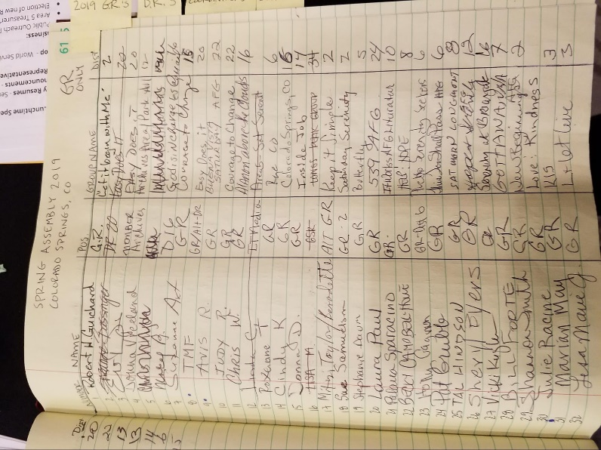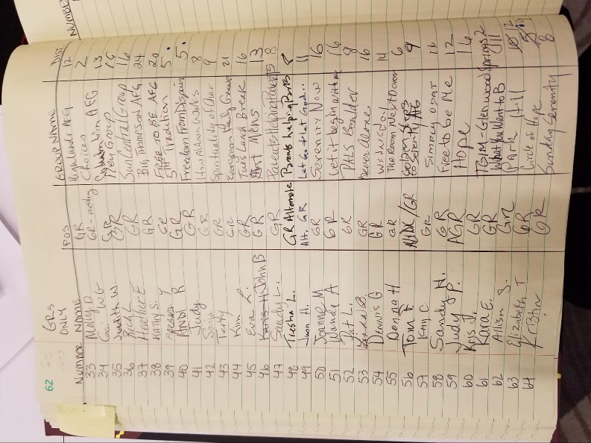
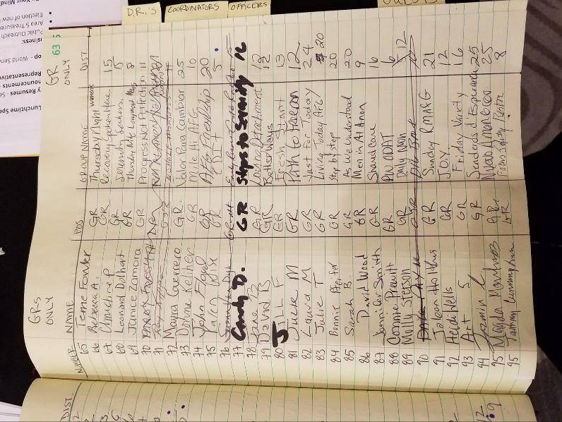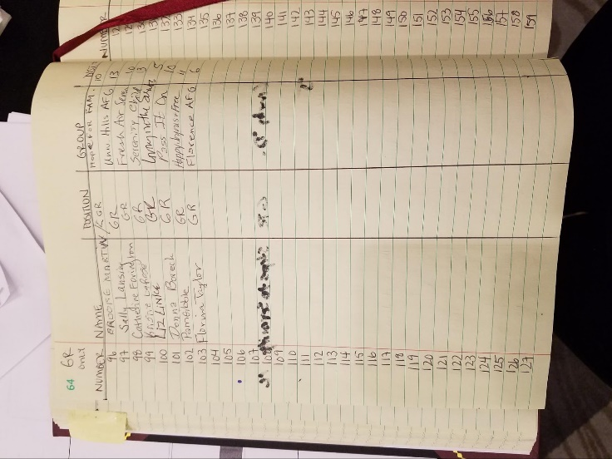
Addendum #2 – Delegate’s Report
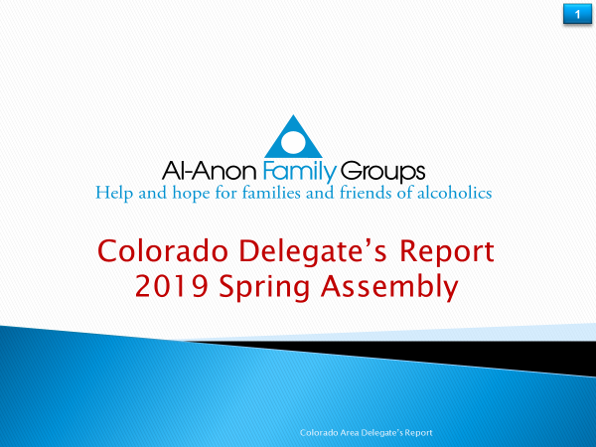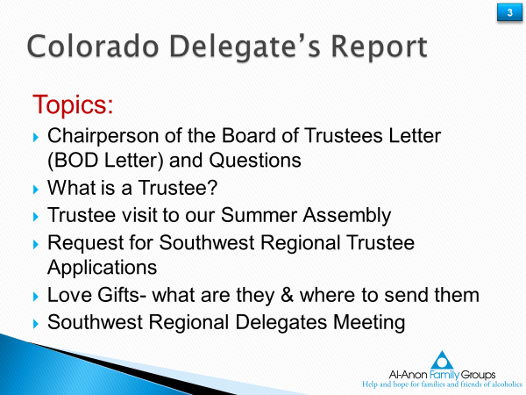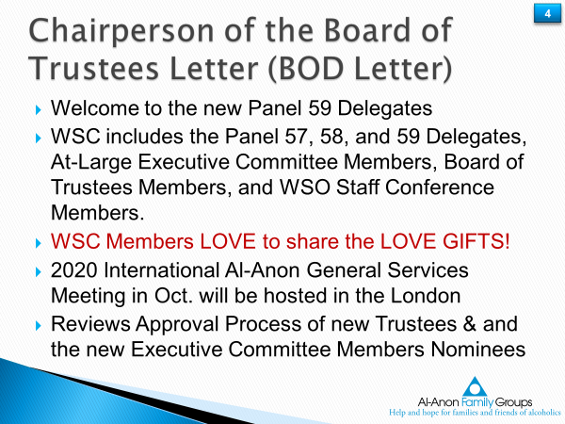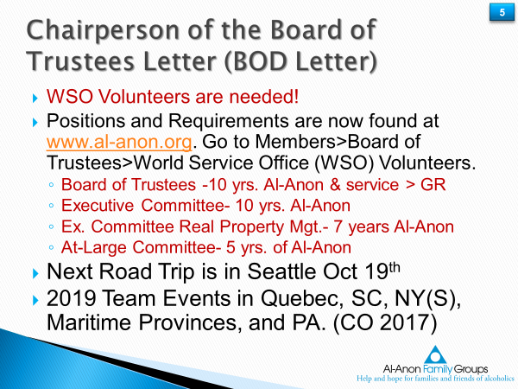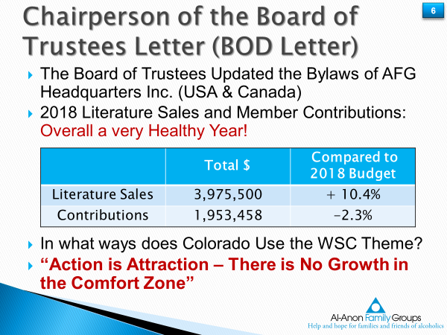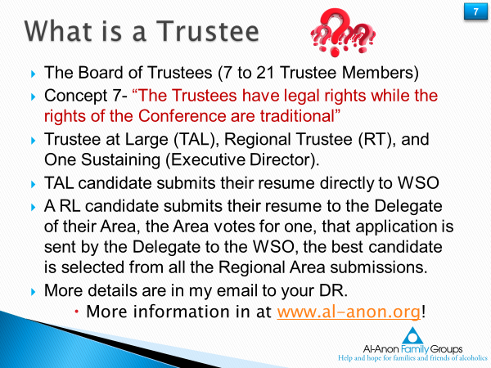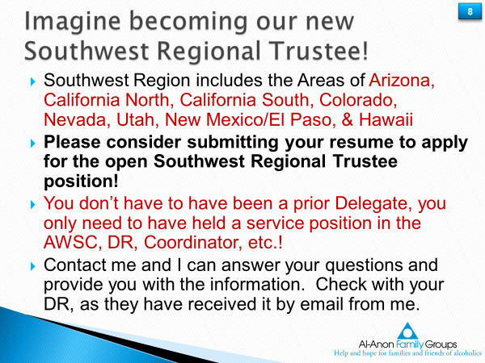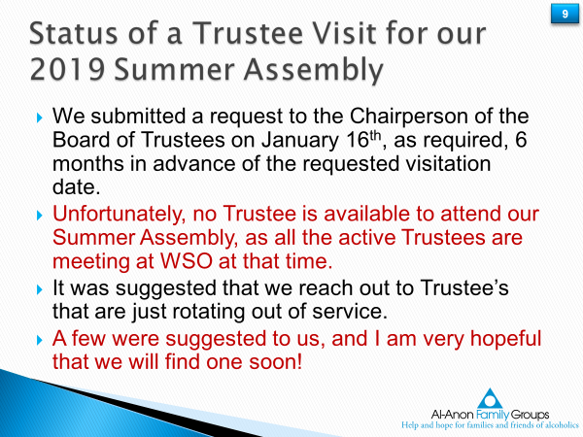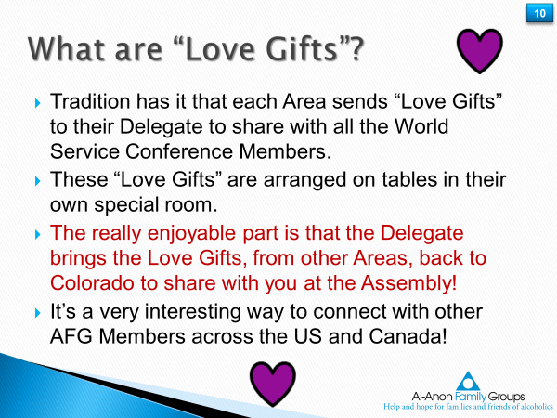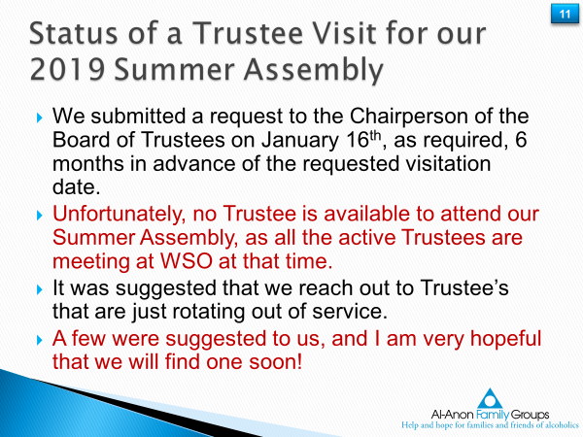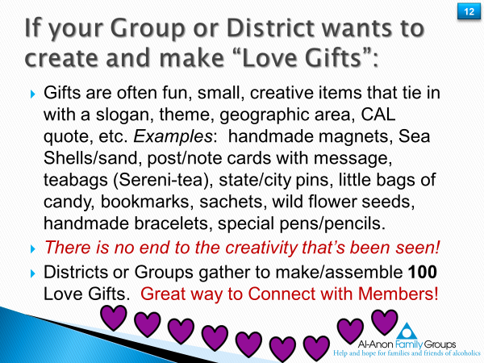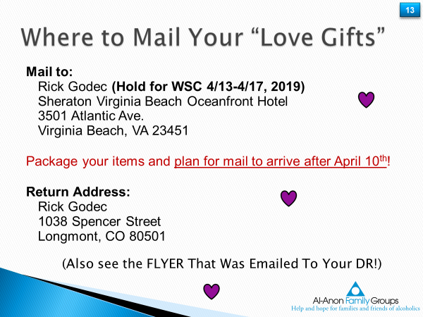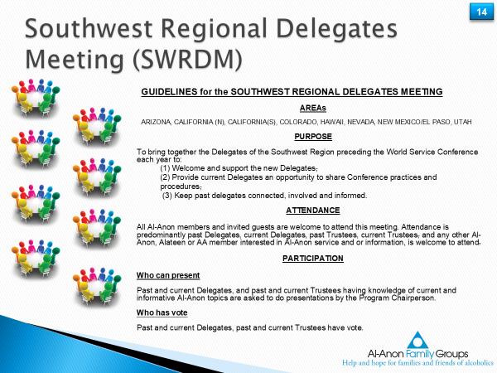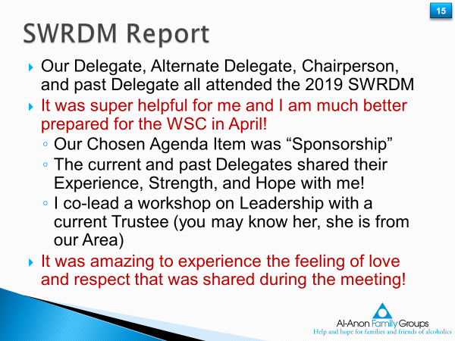

Addendum #3 Spanish Translation Task Force
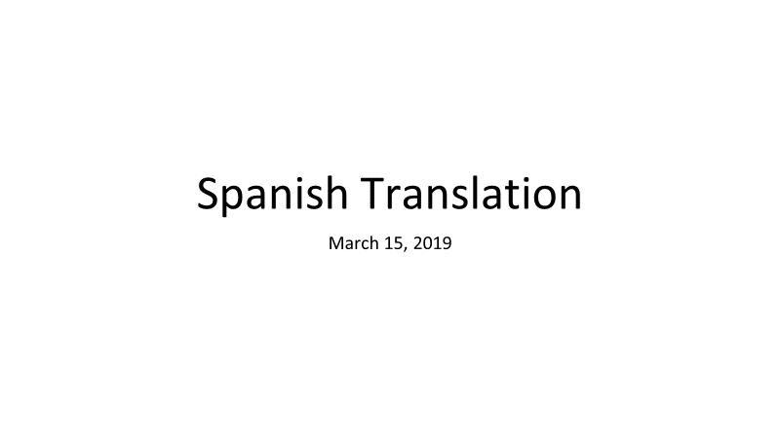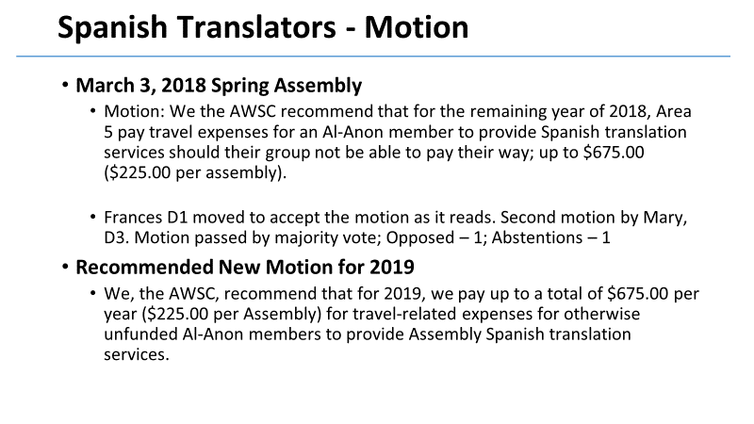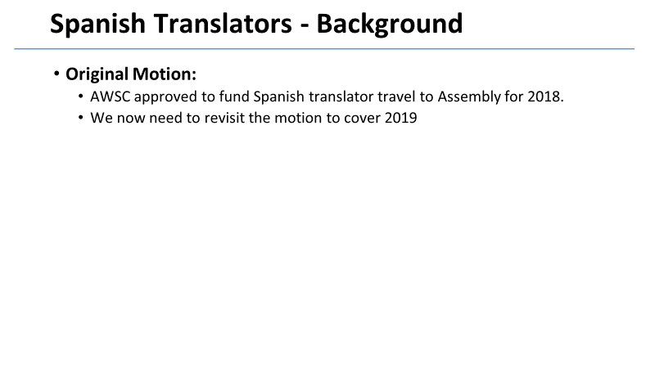

Addendum #4 Alt Delegate 2019 Budget Presentation
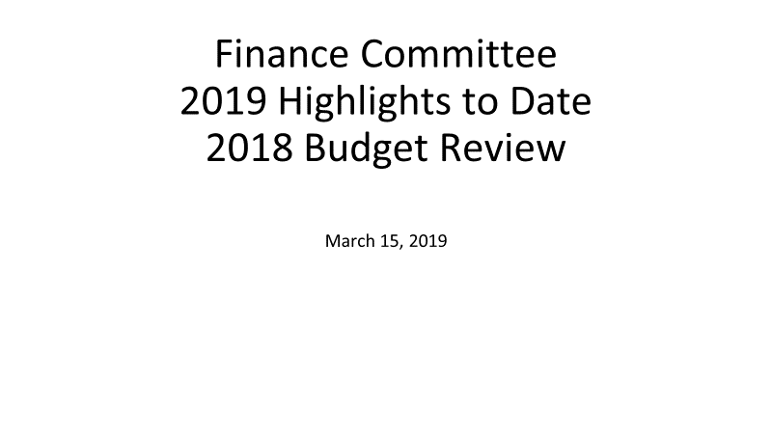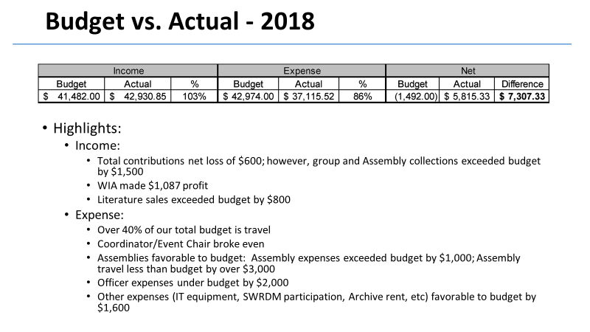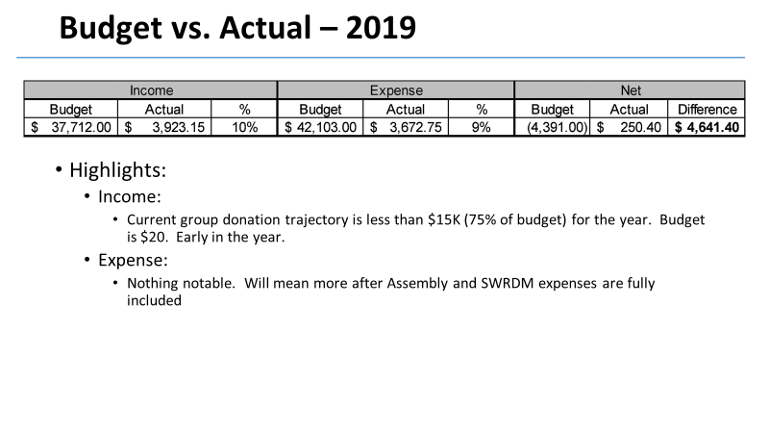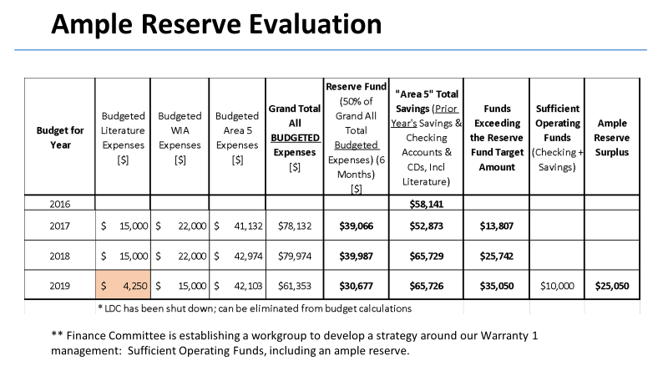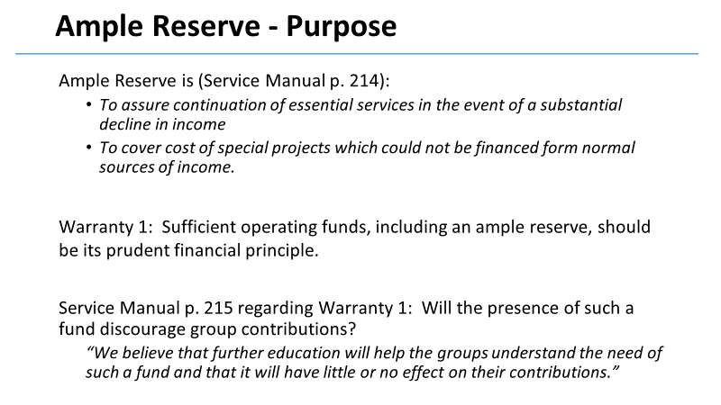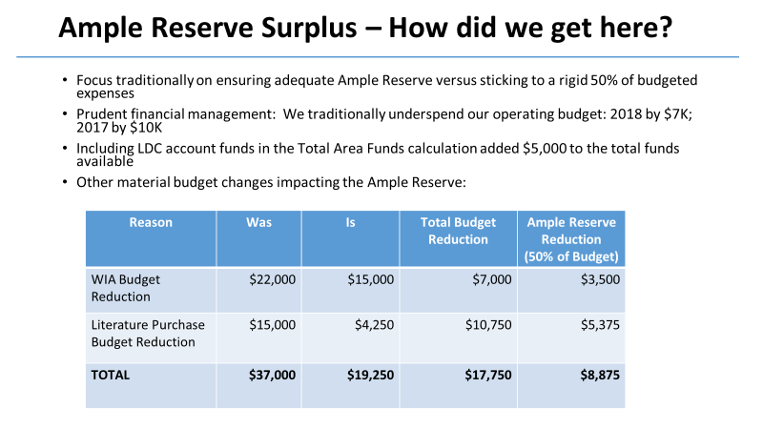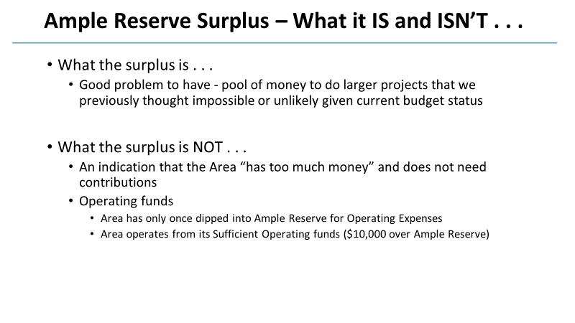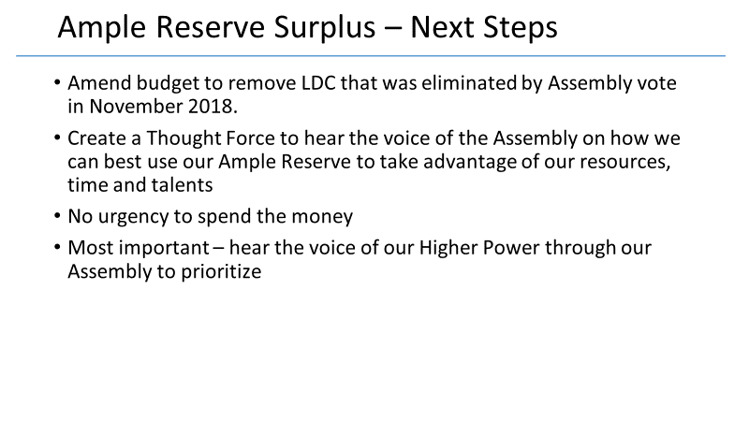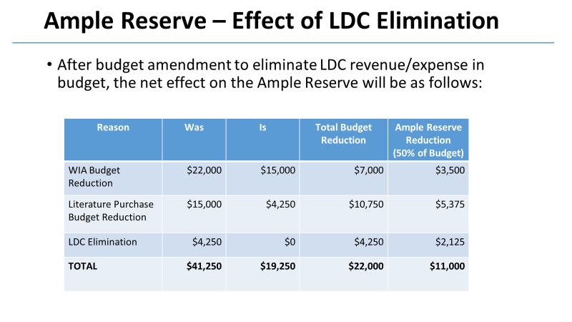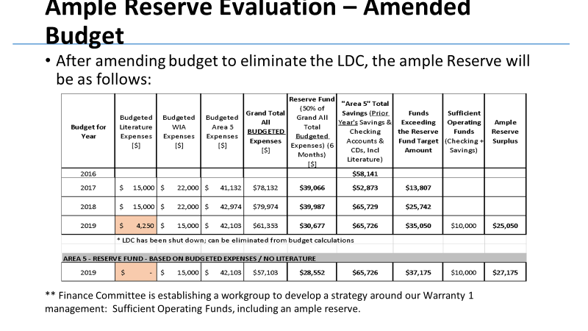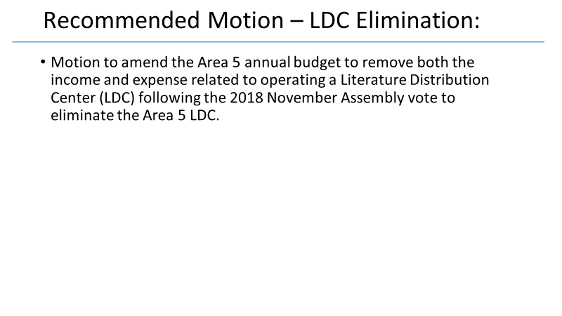
Addendum #5 Literature Coordinator Position Update & Discussion –
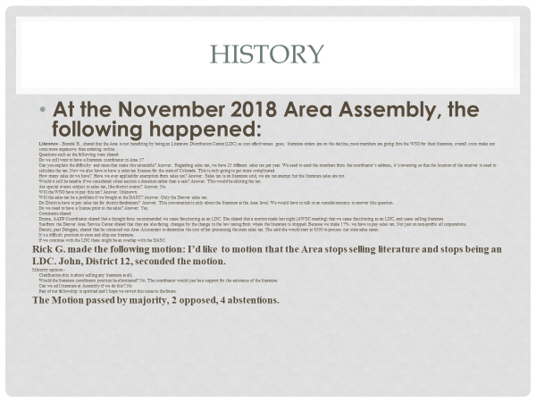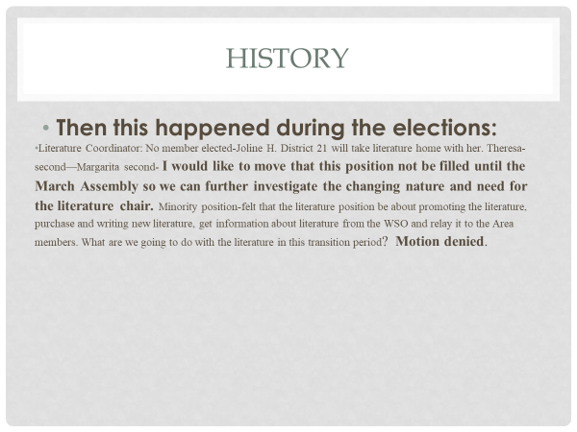
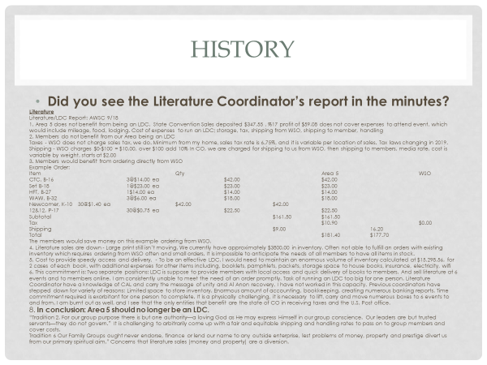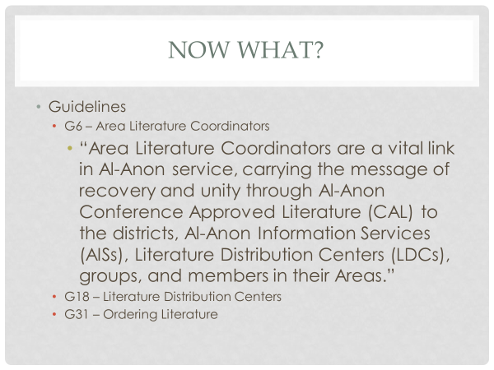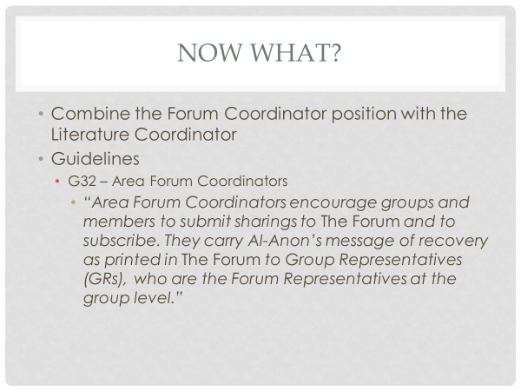
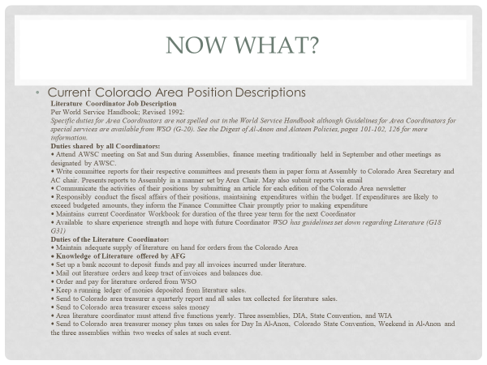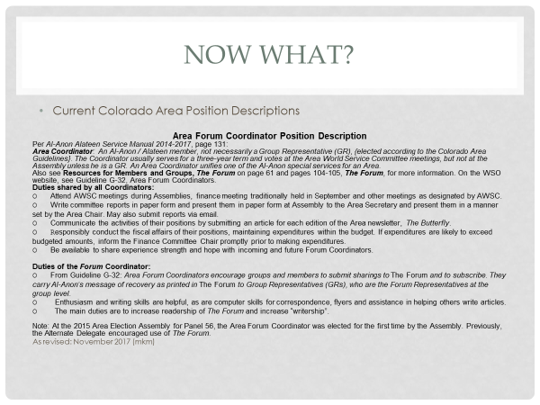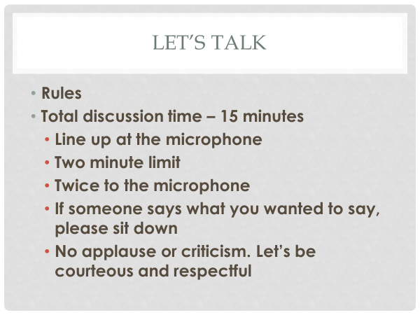

Addendum #6 Hot Topics – Delgate Presentation –
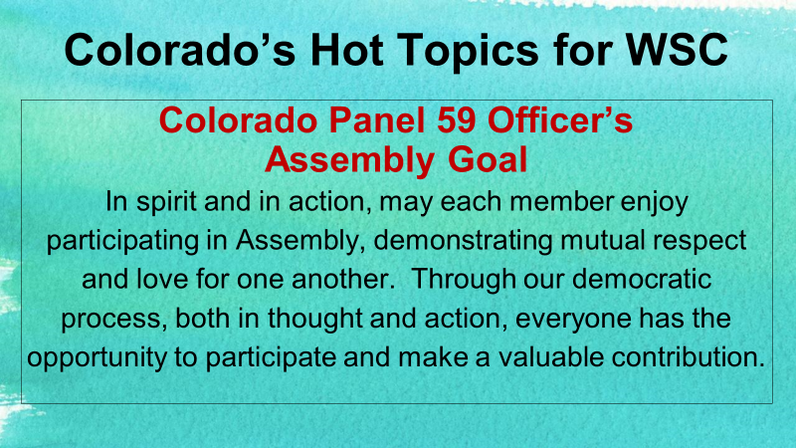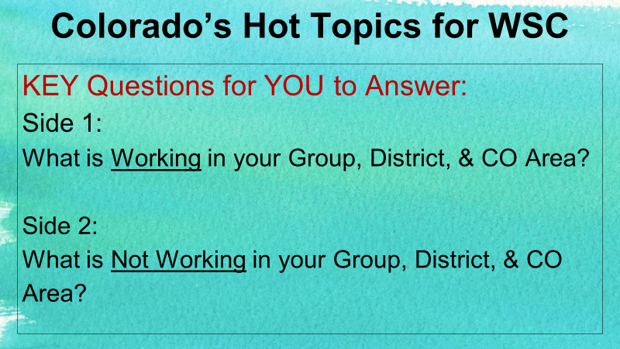

Addendum #7 Think Abundantly – Treasurers Presentation –
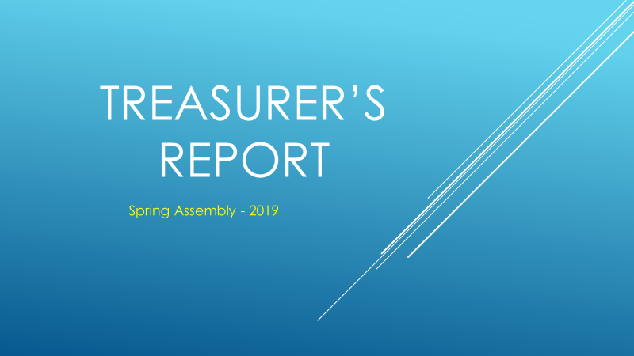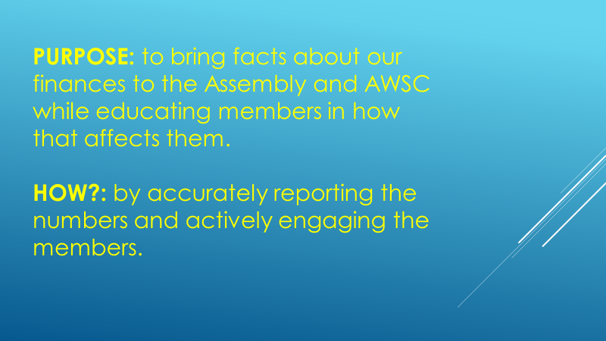
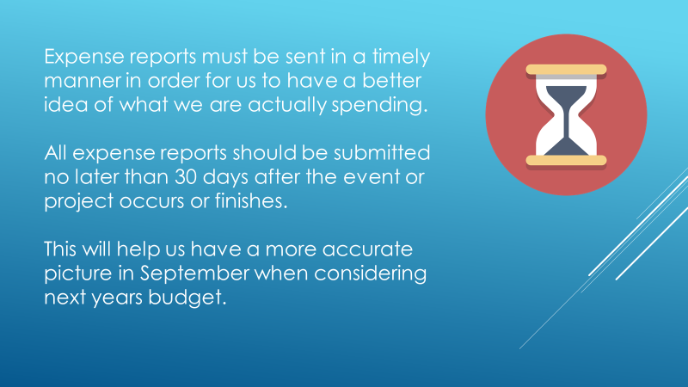
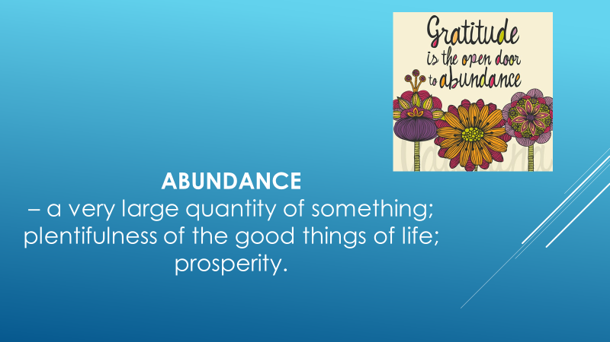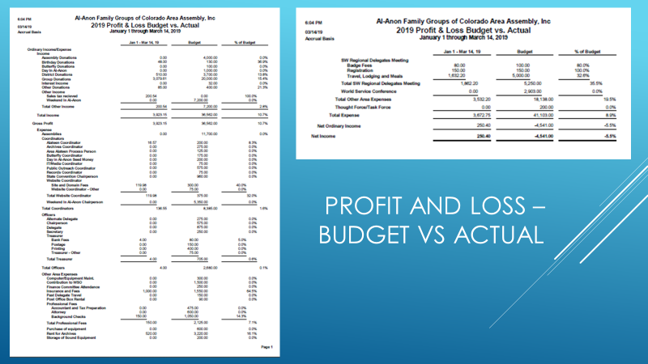
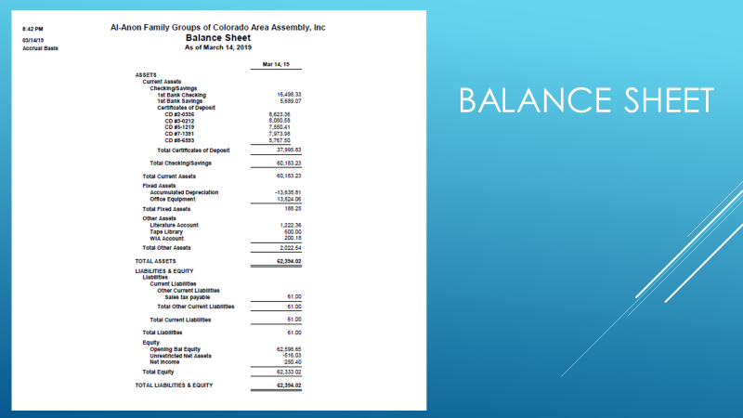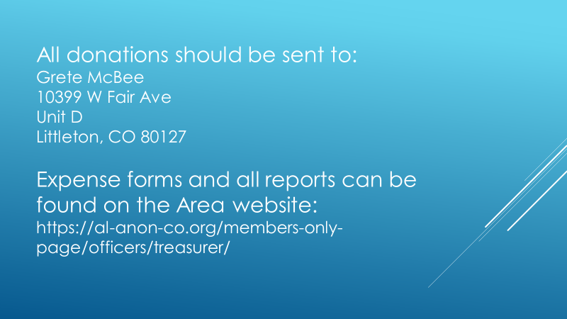

Addendum #8 What’s On Your Mind Presentation–
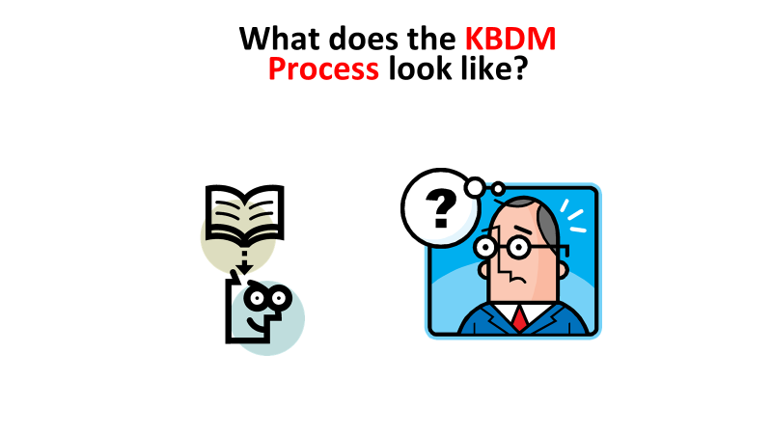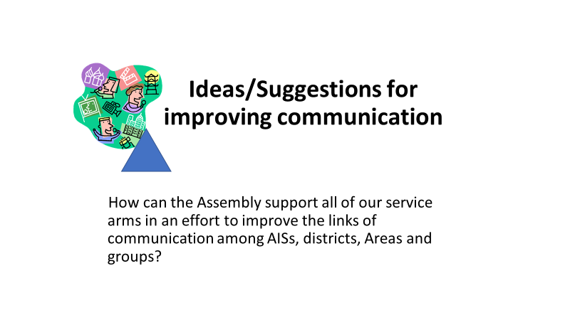
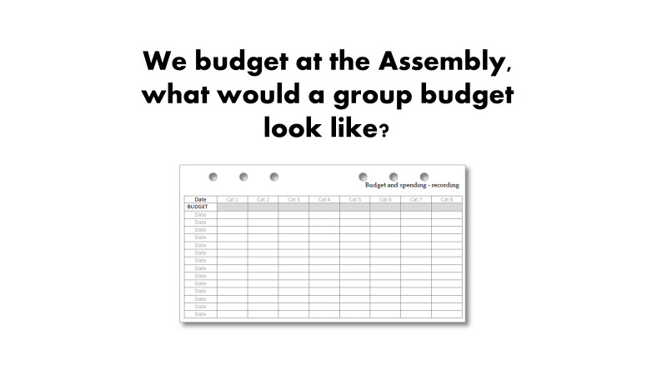

Addendum #9 GR Breakout–
